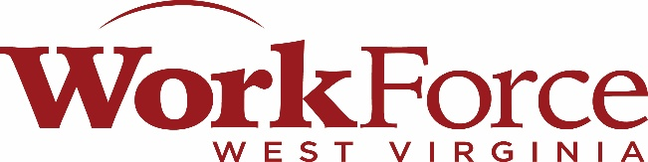

Region VII Workforce Development Board

Program Coordinators Report

Labor Market Update

National and state unemployment rates remained relatively stable throughout the past several months, indicating continued labor market resilience. National unemployment remained at 4.3% in both March and April 2026, while West Virginia’s unemployment rate declined slightly from 4.7% in February to 4.5% in March 2026, reflecting modest employment growth and continued WorkForce demand.

West Virginia Unemployment Rate

Despite these positive indicators, many working families continue to face financial strain due to rising living costs. Increased expenses related to fuel, utilities, groceries, and transportation continue to impact household stability, even among those who have recently secured employment. Recent inflation reports showed continued increases in energy consumer cost, placing additional pressure on commuting workers and rural communities.

Household Cost of Living Increase

As Workforce needs continue evolving, emphasis remains on connecting individuals not only to employment opportunities, but to sustainable wages and long-term career pathways that support economic self-sufficiency.

I would also like to take this time to speak on our current JACK numbers. So far this year we have reached over 9,684 individuals through the JACK referral system. Using this tool, clients were able to be referred to the partner agencies that were best suited to assist their needs. This puts our grand total of clients who have used the JACK system at 17,954.

