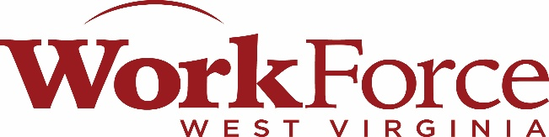

Region VII Workforce Development Board
Dr. Thomas J. Van Meter
Executive Director’s Report
June 11, 2026

Immersive Technology Bill to Modernize Workforce Training and Prepare American Workers for Jobs of the Future
H.R. 6968 Immersive Technology for the American Workforce Act – This bill has been introduced to expand the use of virtual reality, augmented reality, and simulation-based training tools to strengthen workforce development programs and better prepare American workers for in-demand, high-skill jobs.
- Establishes a grant program at the Department of Labor to support the development and implementation of career pathways that leverage immersive technology
- Supports programs at community colleges and career and technical education schools
- Encourages strong industry and sector partnerships to align training with real workforce needs
- Expands access to training for individuals with barriers to employment, including individuals with disabilities and workers in rural communities

Workforce Development Modernization Act
Workforce Development Modernization Act – This bill would amend the Workforce and Innovation Opportunity Act (WIOA) to give local Workforce Development Boards the option to create virtual One-Stop Centers, share resources with other workforce development regions and One-Stop Centers, or co-locate at community colleges. This legislation would expand access to employment resources by allowing job seekers to gain information about in-demand jobs and training online, while also addressing labor shortages.

Employer Directed Skills Act
Employer-Directed Skills Act – This bill was reintroduced and is intended to revitalize America’s workforce by streamlining businesses’ access to skills programs under the Workforce Innovation and Opportunity Act (WIOA). This legislation would give American businesses the opportunity to identify prospective employees to participate in training programs and select or design the training program that best meets their needs, while accessing WIOA funds to offset training costs.

A Stronger Workforce for America Act of 2026
H.R. 8210 – The House Committee on Education and the Workforce completed a markup and approved the “A Stronger Workforce for America Act of 2026”. The bill would reauthorize the Workforce Innovation and Opportunity Act (WIOA) and reflects many provisions included in earlier versions of the bill considered in 2024.
- 50% of WIOA funds required to be spent on training
- States with less than 5.1M people would be state-run systems
- Gives states/governors more power to consolidate or eliminate local workforce boards

Streamlining Timely Apprenticeship Registration and Transparency Act (START Act)
This legislative bill was introduced to guarantees prospective programs will receive faster responses as they seek registration, so industries that are unfamiliar with apprenticeships will be able to participate with ease.
Apprenticeship Data Value Improvements to Create Employment Act (ADVICE Act)
This legislative bill was introduced to make it easier for states and apprenticeship program sponsors to measure success in apprenticeship models by allowing them to create critical pay, retention, and program completion data. This will help states and apprenticeship program sponsors replicate proven models so more workers will have opportunities to participate.

